**PHP MySQL CRUD Application**

**១.តើ CRUD គឺជាអ្វី?**

CRUD គឺមកពីពាក្យ​ **C**reate(បង្កើត), **R**ead(អាន), **U**pdate(កែប្រែ), និង​ **D**elete(លុប)។

ប្រមាណវិធី CRUD គឺ​ជាមូលដ្ឋាន​បង្កើត​ទិន្ន​ន័យ​សម្រាប់ Database។ យើងនឹង​បង្កើត​ table ដែល​នឹង​ត្រូវបានគេប្រើប្រាស់​ដើម្បីផ្ទុក​ទិន្ន​ន័យ ក្នុង​ Database។

២.បង្កើត​ Database Table

Execute the following SQL query to create a table named employees inside your MySQL database. We will use this table for all of our future operations.

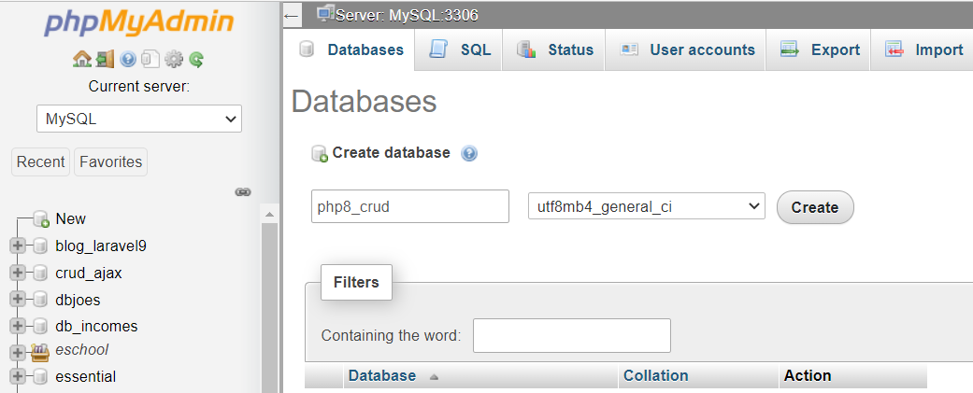

CREATE TABLE employees (

    id INT NOT NULL PRIMARY KEY AUTO_INCREMENT,

    name VARCHAR(100) NOT NULL,

    address VARCHAR(255) NOT NULL,

    salary INT(10) NOT NULL

);

Creating the Config File

After creating the table, we need create a PHP script in order to connect to the MySQL database server. Let's create a file named "**config.php**" and put the following code inside it.

We'll later include this config file in other pages using the PHP *require_once()* function.

<?php

/* Database credentials. Assuming you are running MySQL

server with default setting (user 'root' with no password) */

define('DB_SERVER', 'localhost');

define('DB_USERNAME', 'root');

define('DB_PASSWORD', '');

define('DB_NAME', 'php8_crud_db');

/* Attempt to connect to MySQL database */

try{

    $pdo = new PDO("mysql:host=" . DB_SERVER . ";dbname=" . DB_NAME, DB_USERNAME, DB_PASSWORD);

    // Set the PDO error mode to exception

    $pdo->setAttribute(PDO::ATTR_ERRMODE, PDO::ERRMODE_EXCEPTION);

} catch(PDOException $e){

    die("ERROR: Could not connect. " . $e->getMessage());

}

?>